Assignment M5

Lu Han  
lhan72@gatech.edu

***Abstract—*** Zara is a popular fast fashion brand but its website suffers from low usability and bad user experience. In the needfinding study, it was found there was a huge gulf of execution and evaluation within the interface. This project aims to redesign the website interface and improve its functionality and usability. The project will focus on the task of shopping on Zara website which includes the subtask of searching for products, viewing search results, filtering and sorting the results and etc. The redesign of Zara website with main tasks and subtasks will be evaluated by different evaluation methods: qualitative evaluation and predictive evaluations.

# qualitative evaluation

## Evaluation process

The qualitative evaluation took place in the form of online survey. The survey was posted two weeks ago on the peer survey platform. The survey includes nine questions which may take around 2 min to finish. In the end, 25 responses were collected online and there is no supervision around the survey so people use the website or mobile device to answer the questions by themselves.

## Results of survey

The raw survey results in csv format and survey were attached in appendix. The survey consists of 9 questions of which 2 of them are open ended questions. The first two questions ask about how people search for products on Zara website and how frequently they use either searching options. And the results shows that participants use the searching bar and navigation button to search for products frequently, as average frequency equal to 4.2 and is representative to the level of frequently. And one person says that he uses the google search for product searching purpose, which is excluded from our study scope.

The following questions ask people how they feel about the paper prototypes of Zara website header redesign. The questions ask people’s feeling towards the new interface to help them to accomplish the tasks of: be able to find products and find them quickly, showing the product categories clearly, adding saved items to wishlist The average for questions 4 to 7 are 4.0, 4.3, 4.2 and 4.3 respectively, where 4 and 5 means they agree or strongly agree with the statement that the new interface helps them to the tasks more efficiently and successfully.

## Results analysis

I realized that some of the questions in the survey might be leading and cause users to bias their answers. For example the question states that “The new header for Zara will be helpful to find your products”, which people may tend to answer positively as they want to make surveyor happy and try to be nice. However as the survey is closed and it’s not time effective to redo the questions, I decide to keep it as is and improve in the next iteration. Regardless of the desirability bias, the results show that most of the people think that the interface help them to find the products, search products and add products to the wish list in a positive way, as they rated high level of agreement when they evaluate the paper prototype.

The open ended questions for improvement may be more interesting to analyze as people pointed out some interesting ideas that I haven’t thought about in the brainstorming sessions. Two of the participants mentioned about the color coding to make the interface more discoverable. As the paper prototype does not include aesthetic elements, this can be incorporated into a higher fidelity prototype. One comment mentioned that categories can be shown in icon to keep the header consistent with icon signifiers. Another participant mentioned that the categories are overlapping and a quick filter might be needed to help further filtering the products. This is helpful as it may save the user time and cognitive effort to dig further in the category list. By simply hovering the category, the button can show a more detailed subcategory window. This may help the user to simplify the searching steps and make the process more efficient. Overall, the evaluation feedback was quite positive toward the paper prototype, as 21 out of 25 responders say that they will use the search and navigation more often with the new interface.

## Changes in prototype

Most of the feedbacks are positive toward the prototypes regarding its layout, the categories navigation, searching bar and wishlist and shopping bag, while some point out that certain changes can be made to the current version prototype. First, the design can be more consistent by using the icons in the category navigation buttons. Secondly, the login button is not very discoverable and was hidden beside the searching bar and wish list. To make it more discoverable, it can be placed in the very right end. The aesthetic elements such as color, font size can be explored further to match the Zara fashion style. In addition, the category buttons need a subcategory window to show more categories and decrease the overlapping to improve searching efficiency.

# predictive evalution

## Cognitive walkthrough

A cognitive walkthrough was conducted on the card prototype. The card prototype aims to help the user to accomplish the goal of searching and navigating through the categories to find a target product. The user may also want to narrow down the results by sorting and filtering the results and save items to wish list before he confirms which one to purchase.

For the first task of searching and navigation for target products, the user begins by looking at the first card of page header. The user will see the search bar with a signifier of magnifying glass. The signifier helps him to discover and understand the functionality of searching bar. When he clicks on it, a drop down menu shows up and this immediate feedback narrows down his gulf of evaluation and shows him the action is effective and leading to his goal. In the drop down menu, he will see some suggested searching keywords such as “dress””jeans”. Underneath the suggested words, there are also some recent searching history showing him what he has searched before. This teaches the user to take the next step by typing in the keywords related to the products. The user then types something like “jeans” in the searching bar but he may make typos in the process. For example, he may type “janes” instead of “jeans”. The interface should catch the user slip or mistake and give the user opportunity to correct them instead of punishing them. With the typo, the page will show the message of “do you mean jeans” and the user can click on the message to correct the searching results.

Next the user might want to view the searching result in the overview page and adjust the view grid size. The view button was labeled as “view” with a number of “2” and “4” beside it. This enables the user to understand the functionality of the button and the number labels help the user to predict what the page will look like as the number indicates the number of pictures per row. When the user presses the number, the page layout changes accordingly. This helps the gulf of evaluation and the feedback shows user the action is effective. Comparing to the original slide bar without any labels, this new view button affords people to press and predicts the outcome.

Then the user might also want to narrow down the results by sorting and filtering the results. The sort and filter buttons are labeled with text and are self-explanatory. The user discovers the buttons and click on them, as a result, a dropdown button will show the sorting or filtering criteria. The sorting criteria is labeled with text and the box affords selection among the criteria. Once the criteria is selected, the box will be filled and this tells the user that his action is successful. To filter the results, the user will notice the “+” and slide bar in the filter. The “+” is mapping from plus sign in math. The mapping enables the user to predict to see more options when he clicks on the button. The slide bar of price affords user to adjust the price among the bar range. The gulf of execution is minimized as user knows slide bar functionality from volume bar. However when the user wants to cancel the sort or filter options, there is no option for them to cancel the selection. A cancel functions for sort and filter might be needed for users to go back to the original page without unselect the options one by one. If the user wants to sort by price and adjust the price range at the same time, she has to click at least three times on the interface. A more efficient way might be studied to improve the efficiency of the interface. And for some users who rely on the reviews for online shopping, there is no option for reviews. So the sort and filter functions may be further studied to optimize for different users with different needs.

Finally before the user confirms the order, he wants to add items to wish list and decide later. The wish list icon on the up right corner and the bookmark icon on the item can afford the task. The bookmark icon acts as signifier and it’s mapping from book marks that enable users to understand the functionality of it. User discovers the bookmark and clicks on it. As a result, the bookmark was filled and a message above it saying “view wish list” was shown. The feedback helps to narrow the gulf of evaluation and the users can associate his action with the task of adding items to wish list. Another immediate feedback is the wish list on the right corner will show the number of items above it with the addition from user. But if the user want to cancel the wish list adding action, or he made a slip by accidentally press on the bookmark button, an option to cancel the action should be available to reverse the action.

# evaluation summary

## Next iteration

From the evaluations above, there is room for improvements in the next iterations based on the user feedbacks. From the qualitative evaluation, a higher level of prototype might be needed to include the aesthetic elements such as color coding, the layout, the logo, the font and font size. As in the fashion industry, these aesthetic elements are important for people to purchase the products. Furthermore, some people mentioned the efficiency of the interface is also important. As such, a subcategory window may be needed to quickly filter down the products. Also some overlaps between the categories was noticed, so a more accurate category is needed to optimize the navigation process. From the predictive evaluation, the interface did not add the user mistake and user slips into considerations. Some functions such as sort and filter functions need a more efficient cancel option for users to reverse their actions and go back to the original default page to restart the filtering option. Also the add to wish list function can show an option to remove the item from the wish list in case they change their mind or make a slip when they press the button.

## Additional need finding

I will be interested to understand people use interface for online shopping in different context such as working and in public area, or at home. And how the context changes people’s decision and behavior when shopping online. As this interface in the assignment is designed simply for users at home or in a controlled environment without outside noise. And I would also like to know what’s different user’s priority when they do online shopping and what factors makes the most impact on their decisions. For example, some people focus more on price and some more on the fashion trend and the others more on others’ reviews. These findings may be useful to improve the efficiency of the interface and increase the sales in the end.

## Design alternatives & brainstorming & plan

In the next iterations, different design alternatives can be explored using the user scenarios and storyboard method. The user may encounter different scenarios when using the interface. He may be distracted for other tasks and forget about the items in the shopping bag and so the order cannot be finalized. A new design may be explored to study different scenarios for the user and include the task of order checkout and payment in the whole picture.

Some revisions to the current version of the prototypes are needed from the previous qualitative and predictive evaluations, such as including the aesthetic elements into the design, adding certain functions to reverse the actions or cancel the selections. These revisions can help the interface to allow mistakes and slips from the users, and also it can improve the efficiency of related functions.

With the revision of current version of prototypes, a higher level fidelity prototype might be needed to gather more quantitative data to further analyze the prototype. Functional buttons and interactive interfaces can be explored to study the interface efficiency and functionality. For example, data will be collected such as how many errors users make and how many times of clicks they need to accomplish the check out and payment tasks. A quantitative evaluation is needed to quantitatively compare the current interface with the original interface to see which one has a higher efficiency to certain task and tolerance to user mistakes. With the quantitative data, more conclusions can be drawn from the prototypes and revisions can be made according to these feedbacks and we can include the feedbacks into next iterations and see how the revised version goes with these changes.

# appendix

response,Q1,Q2,Q3,Q4,Q5,Q6,Q7,Q8,Q9

1,5,5,I use search button for anything. No time to waste!!! ,5,5,5,5,"I agree with you that current Zara's search button/function is horrible. I bet that they tried to be ""Slick/Cool but It ends up failing. I suggest the use of bright color to attract users",Yes

2,4,4,NA,5,5,5,4,NA,Yes

3,5,5,,3,3,4,4,No,Not Sure

4,4,3,,3,3,3,4,I do not even know how the existing header looks for Zara,Yes

5,5,5,,3,4,4,4,I think the logo should be in its own row/space and not in the same line as that of the categories,Not Sure

6,2,5,,4,4,3,4,NA,Yes

7,5,5,,4,4,5,4,NA,Yes

8,5,4,,3,3,2,3,none,Not Sure

9,4,4,,5,5,4,4,No,Yes

10,4,4,,4,4,4,4,n/a,Yes

11,5,5,,3,4,4,4,color coding in appealing,Yes

12,4,3,Google links,4,4,4,5,Take a look at Amazon app for wishlists,Yes

13,5,5,,5,5,4,4,I like the proposed design. It looks simple to use and efficient,Yes

14,4,4,,4,4,4,4,Nope!,Yes

15,4,4,,4,5,5,5,You may use icons to represent the categories ,Yes

16,4,5,,4,4,4,5,"it looks good, i can't think of any improvements",Yes

17,5,4,,4,5,5,5,No,Yes

18,5,4,,5,5,5,5,No,Yes

19,4,4,,5,5,5,5,N/A,Yes

20,4,3,,4,4,4,4,N/A,Yes

21,5,5,,4,5,5,5,NA,Yes

22,4,4,,4,4,4,4,n/a,Yes

23,4,4,N/A,4,4,4,4,"Maybe quick filters to further filter out the ""woman/man/kids/beauty"" categories",Yes

24,4,4,,4,5,5,5,"Logo can be shifted to extreme left and login button to extreme right. After clicking on any category, a list of sub-categories should be shown",Yes

25,5,3,,4,4,4,4,it seems like there can be a lot of overlap. e.g. there will be products that are in both woman and beauty. Maybe make it so you can select more than just 1?,Not Sure

1. Raw data from online survey for Zara header design

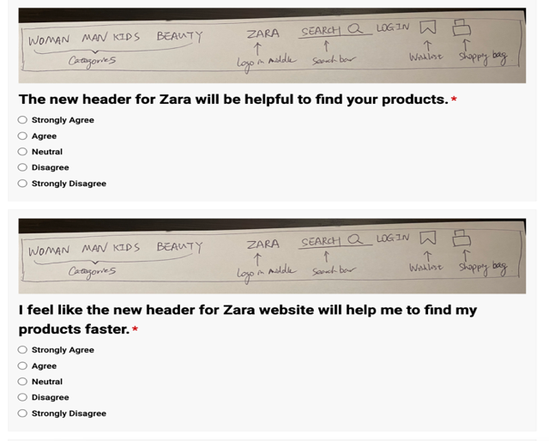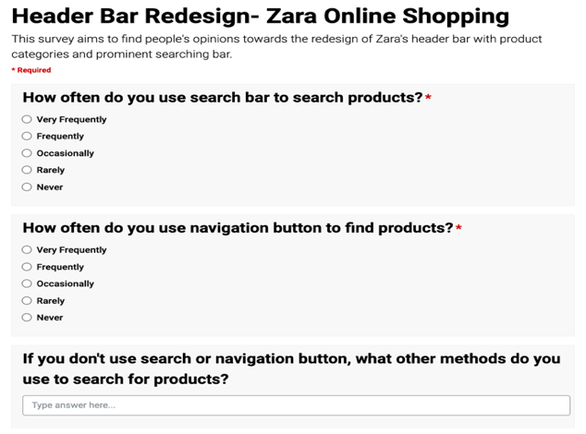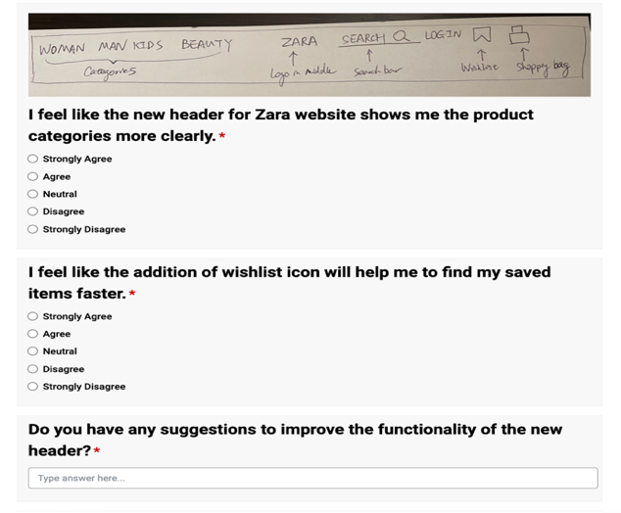

1. Survey questions of Zara header design